|  |  |  |  |  |
| --- | --- | --- | --- | --- |
| |  |  | | --- | --- | | **Here I am,**  **There I go** |  | |  |  | |
| For the Being Human Festival 2016 the Paris Centre for Migrant Writing and Expression coordinated a series of translation workshops with asylum seekers in Paris unable to complete their intended journey to the UK. This work then travelled to London to become an exhibition built in a one-day workshop with foreign students and local Londoners. This brochure contains some of the material and reflection generated through this project.  The photos from the Paris streets are taken from the series Ghosts of Stalingrad © Melissa Thackway.  The photos from the Senate House exhibition are courtesy of the School of Advanced Study © Lloyd Sturdy. |

# We started with Matthew Arnold’s ‘Dover Beach’ and the image of a ‘tranquil bay’. What sorts of translations would we need today to speak between that tradition and the present of ‘Calais’? Would any of the tropes of safe haven from religious or political persecution survive into the contemporary idiom of refugee crisis as it is spoken by the people moved and policed by that crisis?

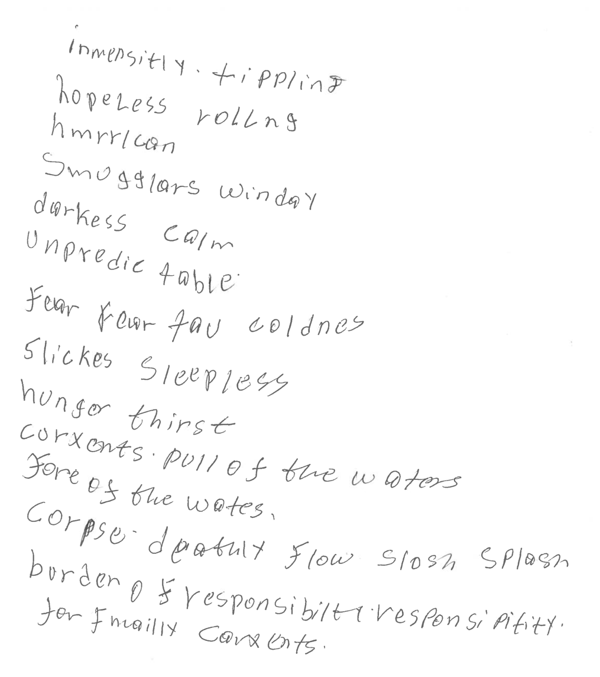

# The answer was few. None, in fact. The vast whiteness of the cliffs, or the eternal roar of the waves translated into descriptions of the number of days at sea, with keen focus on getting the measure of days, and water rations, and fatalities right.

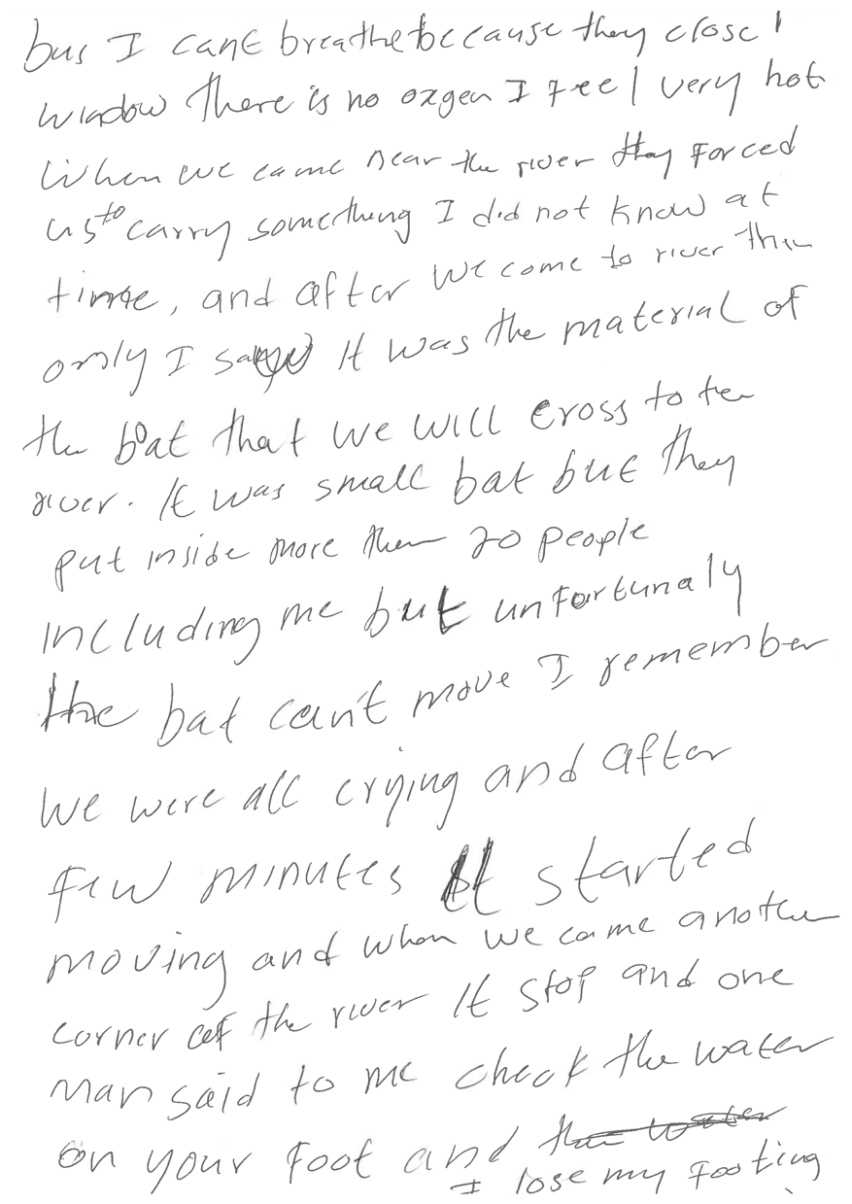

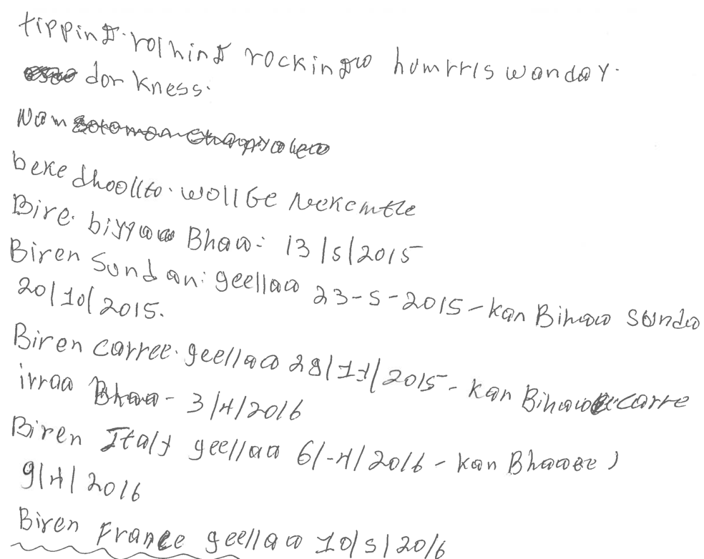

# We talked about noise, about movement. About who had never been on the sea before, and couldn’t swim. We tried a number of words on for size, Laughed at our difficulties, and occasionally we had the impression that our languages could meet in particular sound similarities.

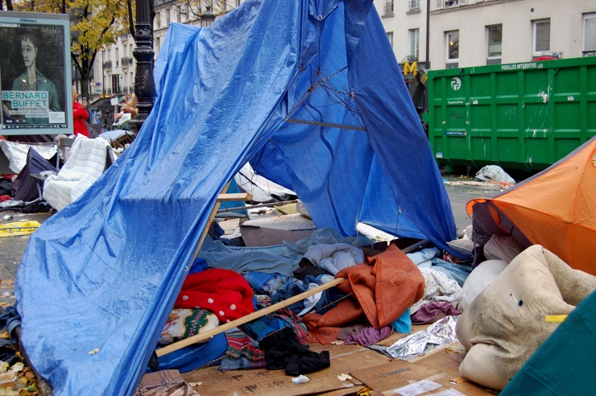 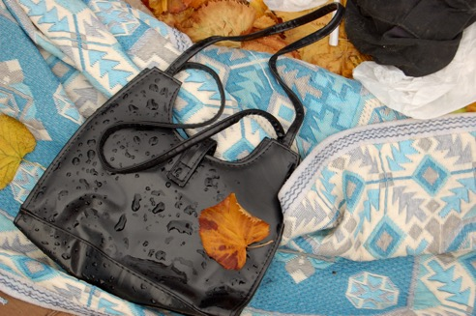

From the project diary, 8 October 2016 (Anna-Louise Milne)

“Random” was your word for the movement that had tossed and terrorised your days at sea, ten in all, and the last ones with a ration of seven dates in the morning and seven in the evening, with some desalination crystals to keep thirst at bay. Ten days of zigzagging “random” skirmishes with the waves between Libya and Italy, a trip that can take a matter of hours, and you had never seen the sea before, knew not how to swim, and all the possessions you had on leaving Libya after months of work to pay your passage lost overboard in the first vessel that ferried you and how many others? More than made it with you to dry land, that much is sure. Ferried you to the inflatable craft that set out across that untranquil stretch, under the scorching sun and the cold of wet nights. We put words on the whiteboard, inadequate words that were the best I could find as I listened: tipping, sloshing, splashing, dazzle, staring… and you, you all talked more and more, the sheer length of time at sea eclipsing the calm of the lecture theatre: ten days, fifteen days, six days; or you who had crossed from Turkey to Greece, for you it was the vanishing of time in the force of the water, no distance but forced at knife point to embark on a raft made of materials you had carried yourself from the bus where you had felt you were going to suffocate, everyone piled in together, old women and young children too. “Materials” was your word, “but not good materials,” you added. We made the boat, not good boat, and then we could not stop, could not turn back, they said the police would come and so we had to go, though it was not possible to all stay up in the water. The knife, pointing, you stepped out, towards the water, and you mimed your gesture as I tried to understand. “You lost your footing”: I wrote it on the board. Yes, you said, yes, yes, I lost my footing, but my words had no purchase on the fear you were describing, grabbing for anything, catching a branch, hauling yourself up, then a rope, a Greek man pulling you in. I lost all sense of sequence, of which shore, as you did then, no idea where you were between there and Europe.

“We are dead anyway,” you said; “that is why we have to, we are dead anyway, so we have to, even though we know we may die.” And you explained the terrible burden too, of knowing that your passage was paid by a debt that your family would have to repay even if they never hear from you again. We are poor, you have to borrow money, and how do you know if you will be able to pay again, when you are in the pit of a small boat surrounded by bodies and water, unable to swim, waving in desperation at the large vessels that pass in the distance, with no navigation. “Random.” Do you know the word “limbo?” I asked. “Les limbes.” I wrote it on the board. I explained: the suspension, not knowing, between two states, between two coasts. Clinging, shouting; no melancholy. There is a proverb, you said. Yes, there is a proverb, and it was you who had left the camp in Yemen, seven years in the camp in Yemen, then the war caught up with you there, and no school ever, so the little English you speak and the Arabic that you know, you learned in the dust of the camp for you said, I have never held a book in my hand, but the proverb you knew meant the limbo of which I was speaking. So your new classmate wrote it down for you, and said it means “between death and life.” I hesitated, your death sounded like “desse.” You apologized, my pronunciation is not good. But it was my listening that was weak, timid. Between death and life, you sounded long the “th,” again and again, and then in your own language. I tried to repeat after you, so you marked the syllables, “Geeri iyo dhimasho dhex deed,” and the final fall of that compressed “d” which I could only come close to by imagining a stutter, or a sob swallowed, was that the life towards which your expression reaches? Between death and life, not life and death. You smiled, you will teach me. Your friend nodded, and prompted you to write more: “dhinac ma jiro dhinac ma jiro dhex da taaganahay.” What does this mean? I asked. It is the proverb, the same thing, between death and life, you explained and you nodded, but it is the proverb. Do you understand?

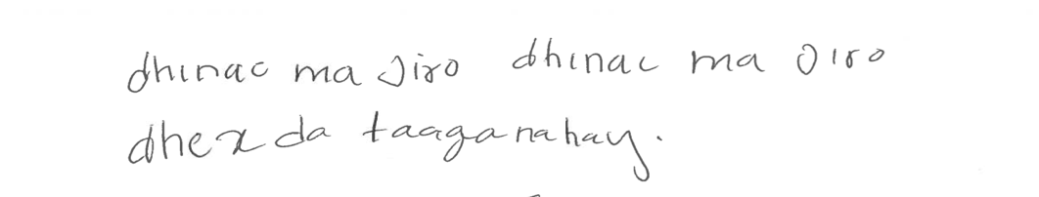

# We worked with more contemporary poems too. Daljit Nagra’s *Look We Have Coming to Dover*, for example, where the waves have become ‘gobfuls of surf phlegmed by cushy come-and-go/ tourists’ and the cliffs are ‘scummed’. The challenges in reading this poem were different, but I don’t think they transformed the direction our project was taking.

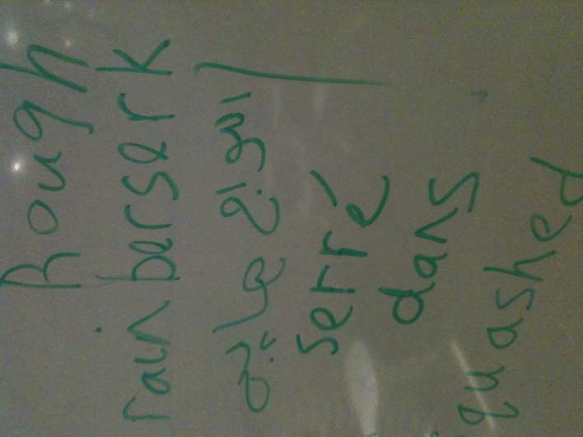The description of ‘yobbish rain’ led us on a long route guided by translation apps to arrive at ‘berserk’, a word that one participant seized upon when I described its etymological origins in Old Norse. He’d spent long, dismal years in Norway where his request for asylum was finally rejected. He feels deeply threatened by the prospect of being returned to Norway under the Dublin regulation, and from there deported. He pulled up photos on his phone of court documents written in Norwegian, expecting me to be able to read them as he can read them. They spell expulsion. He no longer has the originals.

Does it make sense to refer to ‘berserk’ as this participant’s translation of ‘yobbish’? If by translation we mean a re-signifying in a new idiom, then ‘berserk’ would have to be an element in a larger configuration. I don’t think that claim can be made. The mobilisation of ‘berserk’ in that moment of workshop activity cannot be absorbed into the progressive production of a system of communication. It is fully riveted to the hard coordinates of this person’s map, which looks very different to mine.

# Since late October there has been a small statement sprayed on the bridge over the Gare du Nord tracks. It reads ‘Calais is in Paris’, a reminder, if we needed it, that the shape of the map is shifting fast.

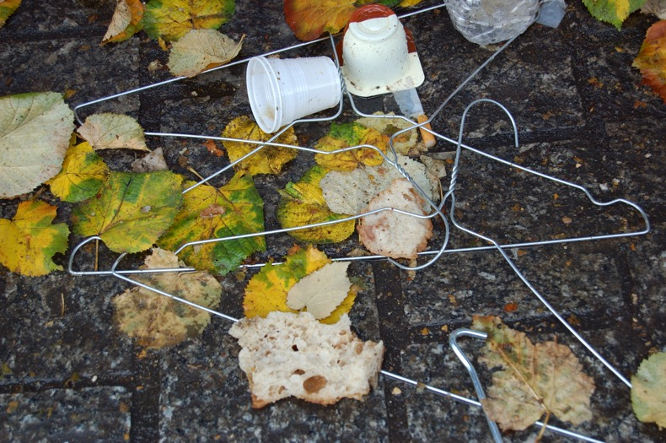And yet of course our maps intersect: ‘Calais is in Paris’ and these people turned up regularly to our classrooms on the rue de Constantine in the shadow of the Dôme des Invalides. So the unexpectedly vital taking up of ‘berserk’ – emphatically repeated in recognition of its aptness – was not fully disconnected. It was a stretch, and it yoked my starting point to a way of describing the world that needs Norwegian, but as the vehicle in this instance of deportation.

**Text that read like a random series of quantities I**s there any sense in continuing to think of these productions in terms of the poetic function of language? If by the poetic we mean the possibility of language reshaping its potential, extracting ‘yobbish’ from its habitual register to recast its force as exposure to the elements, then I’m not sure that this claim can be made either for the way ‘berserk’ acquired sudden purchase in our interactions.

I lost confidence in my turn towards poetry mid-way through this project. It was hard to keep it in the picture when we were trying to find a way of telling the deals struck in Libya against the promise of a sea-crossing, and what the equation was between months of work, abandonment in semi-desert with no means of return and no sustenance, shared living quarters, the threat of jail, beatings, and the eventuality of reaching the coast of Europe.

These accounts came back again and again to variables I couldn’t begin to plot. They were often expressed as numbers noted on a sheet of paper so that at the end of a session, the ‘text’ we had produced read like a random series of quantities without even any trace of the unit of measurement: days, euros, people to a boat…? This is one way of pointing to what seemed to me to have taken us outside the parameters I had imagined as large and permissive of both the translational process and the possibilities for the poetic.

From the project diary, 29 October 2016 (David Aftab Ansari)

I sat next to Iman, a young man from Somalia with whom I had worked quite closely during the last few sessions. He was interested in learning to write in English, and we had previously written the words, “Brother, sister, mother,” as well as expressions such as, “How are you?” This time we wrote out the words, “Flight, boat, and bus,” as well as “hours, days, and years.” This young man’s journey to France was long and circuitous, involving several years in a refugee camp in Yemen, a trip across the Mediterranean in a dinghy, and a flight from Greece to Norway. I asked about each of the stages and how long they took. His friend turned to me at one point and said that it was hard to remember how long everything took, that it just took a really long time and that one just wanted it to be over. I felt that maybe I was asking the wrong kinds of questions and that maybe asking about time was insensitive. Though, a few moments later, Iman pointed to the small bit on the map between Istanbul and where he boarded the boat for Greece said “two hours,” indicating the relatively short bus ride along the seemingly endless route to France.

**Going from pragmatism to a provisional re-routing of language**At this point I reached for what I thought our participants wanted. A key to the University of London, in short. And in practice, some small progress towards the mechanisms of entrance, including an acceptable IELTS score. I’d been struck in the texts that they produced by the difficulties in choosing the right preposition, or any preposition at all. ‘I go bus Istanbul’, ‘I am fifteen days in sea’… So I pulled up some basic exercises from the internet. At least we’ll make some headway on that front.

But I found myself blocked. ‘I am going __ Spain __ holiday’; ‘We went __ train __ Florence’. More trawling would probably have offered better exercises, ones that didn’t pre-suppose a first-world relation to the map, but the very particular stresses on language that these men’s situations generated were what I needed to see. And again their effect was to prompt another unplanned stretch, this time from pragmatism to a provisional re-routing of language.

After lots of free-style sentence work on a white board, the participants chose a preposition from a pile of single words and positioned it on a map within a sentence (the maps were varied, some blank, some with capital cities, some showing the major patterns of recent population movements). The same person I have mentioned already, wrote: ‘I am in Paris because I am under Oslo.’ A short statement of fact, bristling with its adaptive capacities. What claim would I want to make for it as a sentence act? Nothing more perhaps than that, for this person, it is an expression of where he is simultaneously inserted into and denied by the contemporary regime of border control. It is effective and ‘unreceivable’ speech in the same breath, and that breath has gently buckled the map.

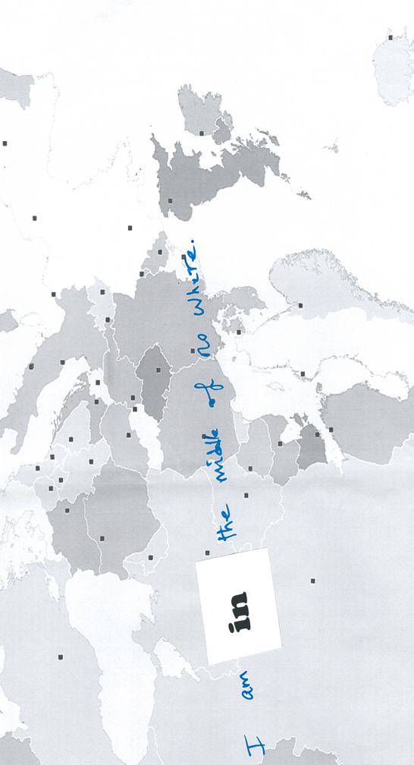

From the project diary, 8 October 2016 (David Aftab Ansari)

At one point, I got up leave the room. On a table next to the door, I saw a copy of *How to Spend It*, a lifestyle magazine geared towards the Financial Time’s more well-heeled readers. The magazine was open to a full page advertisement for a private jet company. In almost any other situation, I might have given the advertisement no more than a glance. However, I couldn’t help but think how strange it was to see the image of airplane carrying a single passenger after having heard these men describe being packed on to vessels that were hardly sea worthy. I wondered, with trepidation, how the men might react if they had seen this ad. After all, being confronted with such an obvious example of the inequalities in mobility certainly made an impression on me. At the end of the session, we discussed plans for the following week. Some of the men made their way out of the room, and others collected the paper cups that we had used for tea. I looked across the room and saw that one man was standing next to the table and leafing through the magazine.

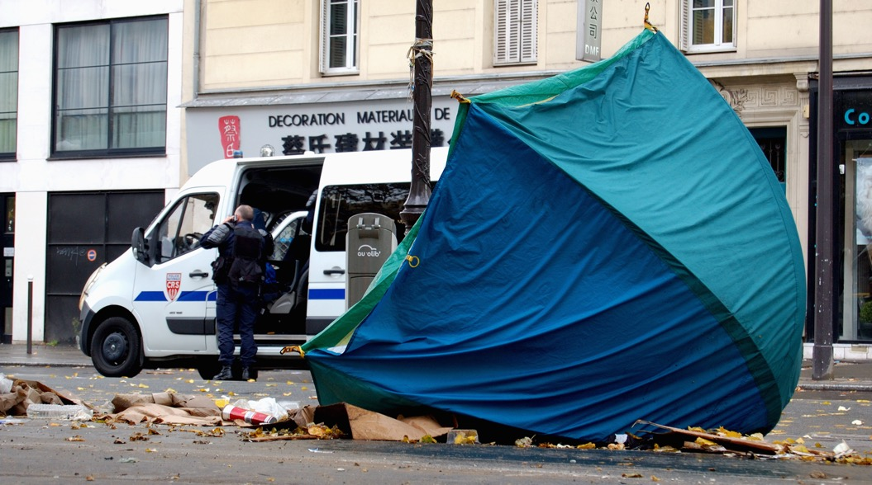

# A group of us gathered in Senate House on a mid-November Saturday under the guidance of Aida Wildes, a London-based Iranian artist, to build an exhibition from the words produced by the Paris participants, drawing also on photographs from the make-shift camps around the Gare du Nord, and diary writings from the project. We had a few hours and lots of paper and tarpaulin.

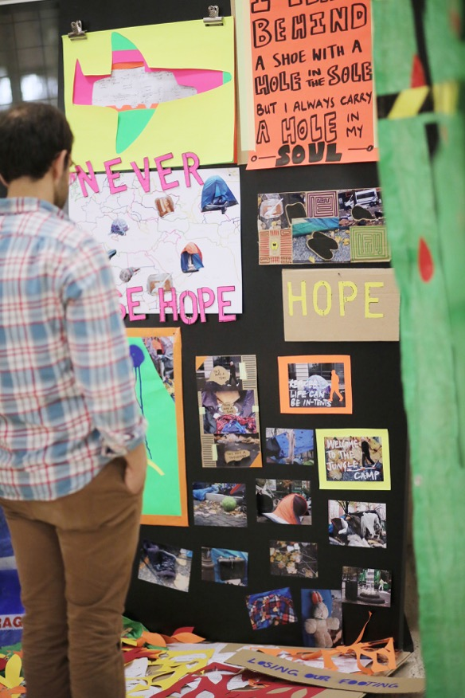I was wary that we might fill the space of the university with an ersatz camp. As it turned out, the constant in the work produced by a variegated group of English-language students from the far corners of Europe, artists from all over and willing-to-try researchers from first-world institutions, was its careful attention to re-positioning. We did a lot of cutting out – abandoned shoes from the photos of the camps, letters from sheets of coloured vinyl, small explanatory drawings from a text mapping a route across Europe. What one person cut out, another inserted.

A straight statement: ‘I came from Egypt by foot’ (generated through our work on prepositions) signified starkly on one wall, and read like an unmanageable accumulation of letters on another wall. A toothbrush left along with wet covers and a partially destroyed tent after a forced evacuation, was cut from a photo, leaving an unlikely slit in the picture, then enlarged to become a looming instrument of self-preservation. A small tent-like structure mounted provisionally on cardboard offered a partial view of bits of documentation from the project.

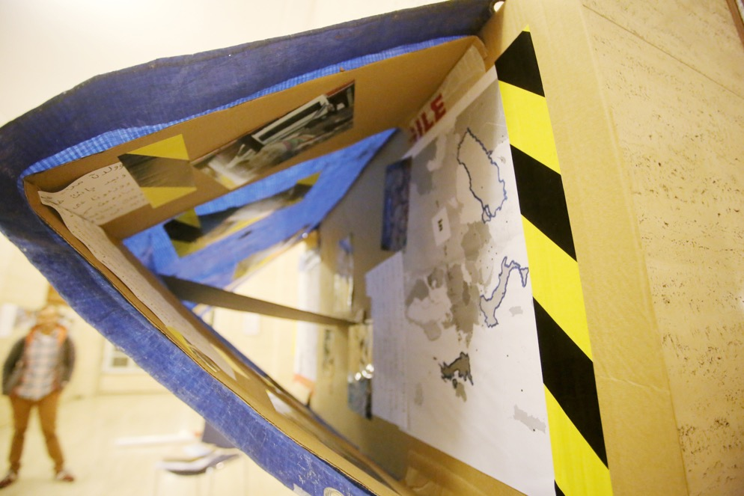

We worked intuitively, with loose awareness of how the work was evolving elsewhere in the room. There was little talking. We were literally processing the words that had been offered us. It was a very purposeful afternoon. We were tired and flat by the end. Perhaps surprised too by the shapes the exhibition had taken.

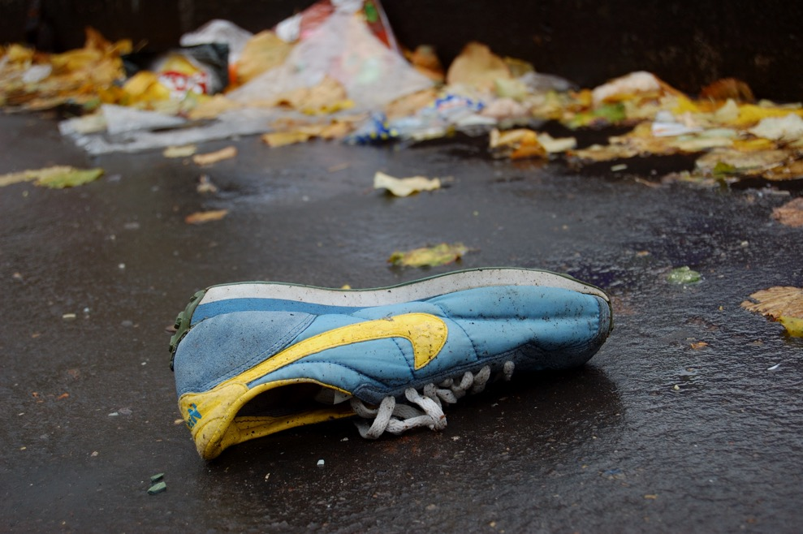

From the project diary, 22 October 2016 (Anna-Louise Milne)

The others have left but you want to explain again, each step associated with figures, 300, 600, 800, the amounts paid – in what currency? – for each part of your journey, for your sisters and your mother too initially, but they’re no longer with you. You are alone, and you are afraid of being sent back to Norway because it is in Norway that you have left your finger-prints, but in Norway too that it was “negative.” Again and again you said “negative” in this story which I was barely grasping, just the numbers and the places, and even then only very approximately, and “negative.” In Norway you said 300, people I think, 300 Somalis and all of you “negative.” You used sheets of paper to signify each person, you would have leafed through the whole ream of paper on the desk, “negative,” “negative” and that word you kept on pronouncing gesturing to something tall, but I didn’t understand, so we tried a translation app on a phone and perhaps we thought it meant court, so you got your phone out too and found a photo of the piece of paper that said “negative” in words I understood much less than yours. Then you wrote the date 2016/11/4, and I read backwards to the realization that this is the date when you think you might be sent back to Norway, and from there perhaps back to Somalia, where you haven’t lived for fifteen years, where no-one of your prior life lives now, where life is under a duress that I can’t begin to quantify or qualify in the way you are working so hard to qualify and quantify your route here. You pull out a paper, your temporary registration under the Dublin procedure, Cergy you say, two weeks, you need help. I scan down the document, your date of birth is given as 01/01/1991, your name as “known as,” your address is a “plateforme d’accueil,” a welcome platform. Your existence on paper is so slight, and yet here you are, wearing a flecked blue jumper with a long necklace of uneven wooden beads around your neck. I haven’t seen you with the necklace before. Perhaps it’s usually under your shirt. I’d like to know more about it. How far it has come with you? But I write down the phone number for the platform, at least I can try calling, and perhaps there will be someone there, out there or up there on that welcome platform – is there a correct preposition for this place of dispatch? – who is willing to help situate you a bit more stably on the map, somewhere at the end of that suburban train line. You’re probably still on that train, while I sit here letting the afternoon slip away into another autumnal evening in Paris.

This project was conceived by Anna-Louise Milne, who also wrote the main text here.

David Aftab Ansari (University of Chicago) was a major force throughout the workshops.

Aida Wilde led the London workshop with Keir Ralph, Felicity Taylor and Juliette Stuart.

Michela Pomati brought along her students and her enthusiasm.

Michael Eades was a constant support and much appreciated interlocutor throughout.

Funding from the Being Human Festival was gratefully received.

All those who joined the workshops despite the unpredictability and difficulties of their current situations are hereby thanked most deeply.

# More on this project and its future iterations can be seen on [www.allophonia.hypotheses.org](http://www.allophonia.hypotheses.org)

 